Neil Yetz

ERHS 642: Logistic Regression

03/03/2016

Dr. Bachand

**ERHS 642 Logistic Regression Spring 2016**

**Homework Assignment 4 – New Version**

1.

a. HL Chapter 3, page 88, question 4 (assess confounding, multiplicative and additive

interaction)

**Assessing Confounding:** Compare the Crude OR vs the Adjusted OR With and without TYP.

**Table 1.10:** Crude OR for Proc Logistic of CAN With STA as the outcome variable.

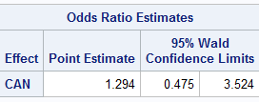

**Table 1.11:** Adjusted OR for CAN with TYP variable causing adjustment With STA as the outcome variable.

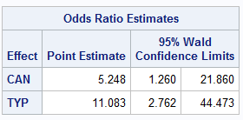

Confounding Check = 🡪 = .753 🡪 **75.3%** TYP is a confounder of CAN.

**Assessing Multiplicative interaction: Run the logistic function with all of your variables and include the interaction variable to check for interaction.**

**Table 1.12:** Analysis of Maximum Likelihood Estimates of CAN, TYP, & CAN*TYP with outcome variable of STA.

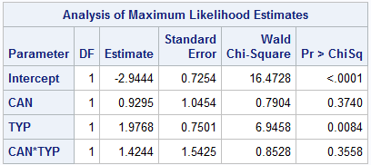

No evidence of multiplicative interaction. p=0.3558

**Assessing additive interaction:** Run the “proc genmod” command with all of your variables and include the interaction variable to check for interaction.

**Table 1.13:** proc genmod analysis of Maximum likelihood parameter estimates for CAN, TYP & CAN*TYP with outcome of STA.

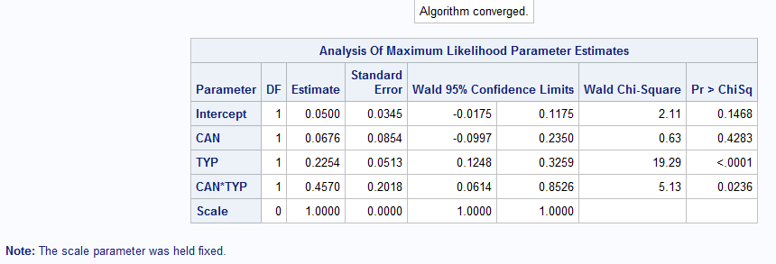

**Table 1.14:** Table of Highest and lowest observations of pihats from proc genmod results.

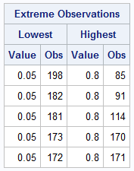

Evidence of Synergistic Additive Interaction. p=0.0236. All pihats between 0 and 1, therefore the results can be trusted.

b. Use contrast statements in proc logistic to create ORs and 95% CIs in a 4-row table;

using the 4-row table reassess multiplicative and additive interaction. Compare your

results to the results from part a.

**Table 1.20:** 4-row table created using contrast statements Comparing CAN, TYP, and Both to a reference category of neither.

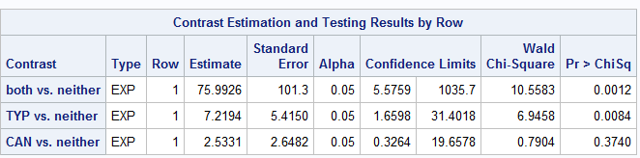

* Multiplicative Interaction: 2.5331*7.2194 = **18.287** 
  + 18.287 < 75.9926. **Evidence of synergistic multiplicative interaction.**
* Additive Interaction: 2.5331 + 7.2194 – 1 = **8.753**
  + 8.753 < 75.9926. **Evidence of synergistic additive interaction.**

**Compared to part a.** We can see discrepancies from our two methods. We obtain the same conclusions of synergistic additive interaction but the discrepancy lies within the interpretation of multiplicative interaction.

In part a, using the proc logistic function, we determined that there is no evidence of synergistic multiplicative interaction; whereas in part b, using contrast statements to create a 4-row table, we determined evidence of synergistic multiplicative interaction.

c. Interpret the ORs and 95% CIs from the 4-row table.

**CAN vs. Neither OR:** Individuals with Cancer as part of the present issue and elective admission into the hospital are 2.5 times as likely to have a vital status of “died” as compared to individuals with neither issue. This odds ratio may range anywhere from 0.3264 to 19.6578.

**TYP vs. neither OR:** Individuals with Emergency admission into the hospital and without cancer as part of the current problem are 7.2 times as likely to have a vital status as “died” as compared to individuals with neither issue. This odds ratio may range anywhere from 1.6595 to 31.4018.

**Both vs. Neither OR:**  Individuals with Cancer as part of the current problem and an emergency type of admission are 75.9 times as to have a vital status of “died” as compared to those with neither issue. The odds ratio may range anywhere from 5.5759 to 1035.7.

d. Note that the ORs in the 4-row table have very wide 95% CIs. Use cross-classification

tables (proc freq) to determine why this is the case.

**Table 1.30:** Frequency table of outcome STA and exposure CAN controlling for TYP.

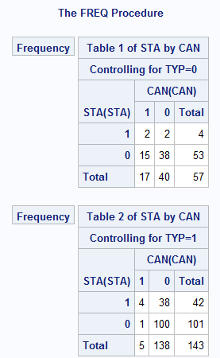

As can be seen from our frequency tables, our cell divisions are not evenly distributed and not many individuals with an emergency type admission had cancer. Therefore, because of the low cell frequencies, our assumptions are not met and this leads to large confidence intervals, thus leading to a lack of confidence in the interpretation of our odds ratios. This is an explanation as to why we are getting differing answers for synergistic multiplicative interaction when comparing our 4-row table to the standard interaction proc logistic function.

2.

a. HL Chapter 3, page 88, question 5 (for 5a, show that age IS a confounder; assess

multiplicative and additive interaction)

**Table 2.10:** Crude Odds Ratio for INH_INJ with outcome of DEATH

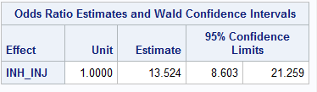

**Table 2.11:** Adjusted Odds ratio for INH_INJ with AGE with and outcome of DEATH.

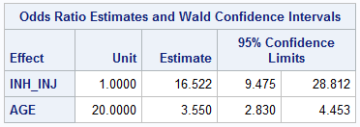

Confounding Check = 🡪 = **0.1814** 🡪 18.14% Age is a confounder of INH_INJ.

**Checking for Multiplicative Interaction.**

**Table 2.12:** Analysis of Maximum Likelihood Estimates of INH_INJ, AGE, and INH_INJ*AGE with an outcome of DEATH.

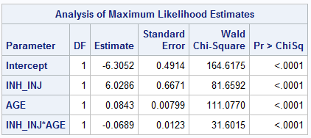

Evidence of Antagonistic multiplicative interaction p<.0001.

**Checking for Additive Interaction**

**Table 2.13:** Table created using proc genmod Using INH_INJ, AGE, and INH_INJ*AGE with outcome of DEATH.

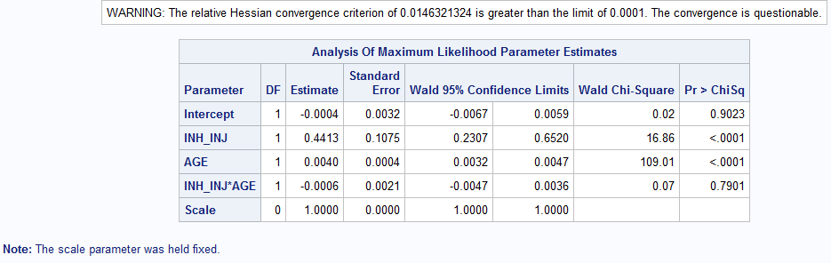

**Table 2.14:** Proc Univariate function showing the minimum and maximum of the phats created from the proc genmod statement in Table 2.13.

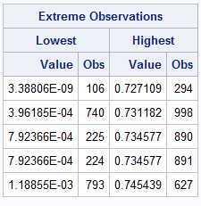

No evidence of additive interaction p=0.7901. Please note: Results are questionable due to the extreme low phat values as listed in table 2.14.

**Creating an interaction model separated by AGE 20, 40, 60, & 80.**

**Table 2.15:** Contrast statements with Odds Ratios INH_INJ yes vs no divided by AGE 20, 40, 60, & 80 with an outcome of DEATH.

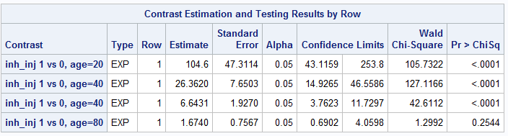

**Figure 2.10:** Odds Ratios by Inhalation Injury (INH_INJ) for ages 20, 40, 60, & 80 for Outcome DEATH.

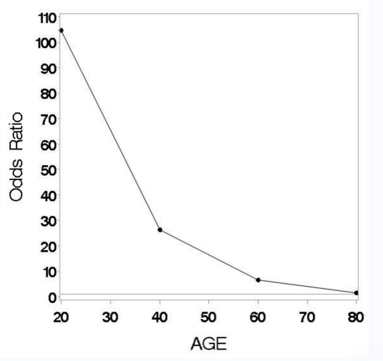

**Figure 2.11:** Odds Ratios by Inhalation Injury (INH_INJ) for ages 20, 40, 60, & 80 for Outcome DEATH with 95% Confidence bands.

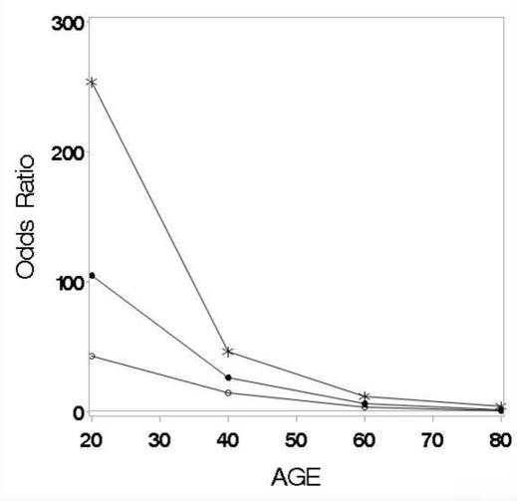

b. Interpret the ORs and 95% CIs obtained from the contrast statements in part a. Why do

the results make sense intuitively?

* At Age 20, a person with an inhalation injury are 104.6 times as like to die as a person without an inhalation injury. The OR is statistically significant, but can vary from 43.1159 to 253.8.
* At Age 40, a person with an inhalation injury are 26.36 times as like to die as a person without an inhalation injury. The OR is statistically significant but can vary from 14.9365 to 46.5586.
* At Age 60, a person with an inhalation injury are 1 times as like to die as a person without an inhalation injury. The OR is statistically significant but can vary from 3.7623 to 11.7297.
* At Age 80, a person with an inhalation injury are 1.67 times as like to die as a person without an inhalation injury. The OR is not statistically significant but can vary from 0.6902 to 4.0598.
* It should be noted that for each age interval, especially at the younger ages, the confidence intervals are quite wide, so interpretations should be made with caution.
* **These results make sense intuitively because** with increasing age, the risk of mortality may go down as other causes of death from burn victims may overtake before death by an inhalation injury. For example, if we were to look at another variable such as heatstroke with an outcome of death, it is very possible that older adults die from the heat of a fire before the inhalation.
  + Furthermore, it is possible that younger burn victims are more often in incidents where smoke is a larger factor (i.e house fires), which I feel like can maybe be very possible because we assessed and found that age was a confounder of inhalation injuries earlier.

libname sdat 'C:\Users\ndyet_000\Desktop\Class Folders\Spring 2016\ERHS 642\Data';

/*data sdat.LOWBWT_altered; set LOWBWT_altered; run;*/

**data** ICU_altered; set sdat.ICU_altered;

**run**;

*Question 1a.;

**proc** **logistic** descending data = ICU_altered;

model STA = CAN;

**run**;

**proc** **logistic** descending data = ICU_altered;

model STA = CAN TYP;

**run**;

*.753 -> 75.3% EVIDENCE OF CONFOUNDING;

**proc** **logistic** descending data = ICU_altered;

model STA= CAN TYP CAN*TYP;

**run**;

*iNTERACT P = .3358 no no evidence of interaction;

**proc** **genmod** descending data=ICU_altered;

model STA = CAN TYP CAN*TYP/dist=bin link = identity;

output out=pdat p=phat;

**run**;

*Yes evidence of additive interaction p=.0236;

**proc** **univariate** data=pdat;

var phat;

**run**;

*needed to run proc univariate to make sure that no values were below 0 or above 1;

*Question 1b;

**proc** **logistic** descending data=ICU_altered;

model STA= CAN TYP CAN*TYP;

contrast 'both vs. neither' CAN **1** TYP **1** CAN*TYP **1**/estimate=exp;

contrast 'TYP vs. neither' CAN **0** TYP **1** CAN*TYP **0**/estimate=exp;

contrast 'CAN vs. neither' CAN **1** TYP **0** CAN*TYP **0**/estimate=exp;

**run**;

**proc** **sort** data=icu_altered;

by descending can descending sta;

**run**;

**proc** **freq** data=icu_altered order=data;

tables typ*sta*can/norow nocol nopercent;

**run**;

*question 2;

/*data sdat.BURN1000_altered; set BURN1000_altered; run;*/

**data** BURN1000_altered; set sdat.BURN1000_altered;

**run**;

*Question 2a;

**proc** **univariate** data = BURN1000_altered;

var AGE;

**run**;

**proc** **logistic** descending data=BURN1000_altered;

model DEATH= INH_INJ AGE/clodds=wald;

units AGE=**20** INH_INJ=**1**;

**run**;

**proc** **logistic** descending data=BURN1000_altered;

model DEATH=INH_INJ/clodds=wald;

**run**;

*Evidence of confounding 18.14%;

**proc** **logistic** descending data=burn1000_altered;

model death=inh_inj age inh_inj*age;

**run**;

**proc** **genmod** descending data=burn1000_altered;

model death = inh_inj age inh_inj*age/dist=bin link = identity;

output out=pdat p=phat;

**run**;

**proc** **univariate** data=pdat;

var phat;

**run**;

**proc** **logistic** descending data=burn1000_altered;

model death=inh_inj age inh_inj*age;

contrast 'inh_inj 1 vs 0, age=20'

inh_inj **1** age **0** inh_inj*age **20** /estimate=exp;

contrast 'inh_inj 1 vs 0, age=40'

inh_inj **1** age **0** inh_inj*age **40** /estimate=exp;

contrast 'inh_inj 1 vs 0, age=40'

inh_inj **1** age **0** inh_inj*age **60** /estimate=exp;

contrast 'inh_inj 1 vs 0, age=80'

inh_inj **1** age **0** inh_inj*age **80** /estimate=exp;

**run**;

* Question 5 *****GRAPHS NOT WORKING!!!!****;

**data** OR; input age OR;

cards;

20 104.6

40 26.320

60 6.6431

80 1.6740

**run**;

**proc** **print** data = OR; **run**;

**data** OR_CL; input age OR CIL CIU;

cards;

20 104.6 43.1159 253.8

40 26.320 14.9265 46.5586

60 6.6431 3.7623 11.7297

80 1.6740 0.6902 4.0598

**run**;

**proc** **print** data = OR_CL; **run**;

axis1 minor=none label=(f=swiss h=**2.5** 'AGE');

axis2 minor=none label=(f=swiss h=**2.5** a=**90** 'Odds Ratio');

goptions FTEXT=swissb HTEXT=**2.0** HSIZE=**6** in

VSIZE=**6** in;

symbol1 c=black v=dot i=join;

symbol2 c=black v=circle i=join;

symbol3 c=black v=star h=**2** i=join;

**proc** **gplot** data=OR;

plot (OR)*age/overlay haxis=axis1 vaxis=axis2 vref=**1**;

**run**; **quit**;

**proc** **gplot** data=OR_CL;

plot (OR CIL CIU)*age/overlay haxis=axis1 vaxis=axis2 vref=**1**;

**run**; **quit**;